# KWAME NKRUMAH UNIVERSITY OF SCIENCE AND TECHNOLOGY,

**KUMASI.**

**COLLEGE OF SCIENCE FACULTY OF PHYSICAL SCIENCES DEPARTMENT OF COMPUTER SCIENCE**



# PROJECT TITLE: MR. ROBERT FRIES WEBSITE

**STUDENT NAME**: **GEBREMESKEL MILLION SOLOMON**

**INDEX NUMBER**: **4612618**

**PROJECT SUPERVISOR: DR. NAJIM USSIPH**

SEPTEMBER, 2021

**CHAPTER ONE**

**INTRODUCTION**

Mr. Robert fries website is a platform where customers can go and access full information about the establishment. It consists of:

1. Full menu: customers can now view the menu in its entirety.
2. An ordering system: customers can order their food directly on the website.
3. Direct MOMO payment gateway: customers can pay for their orders from the website.
4. Contact: contact information and various social media connection.
5. Chat: customers can now chat with customer service or even each other in real-time on the website.
6. Mobile responsiveness: since mobile phones are the most common digital devices, the system is fully mobile responsive.

**BACKGROUND**

Mr. Robert fries is a student favorite food establishment in KNUST with various branches around campus. Since it is a student favorite, it is always in demand.

**PROBLEM STATEMENT**

Since the outbreak of the COVID-19 pandemic, the common advice has been not to gather in large quantities. Unfortunately, that warning falls on deaf ears. There is always a long line which discourages customers from going to buy the food in fear of somehow contracting the deadly virus. The plethora of people essentially drive potential customers away.

**AIM OF PROJECT**

The ultimate aim of this project is to give customers who do not want to physically be present at branch sites in order to get the food they want the platform to be able to order and get their food in the comfort and safety of their rooms. Also, through this same platform, allow Mr. Robert to move on into the e-commerce community which is taking the world by storm. In addition, the platform will help Mr. Robert adhere correctly to COVID-19 restrictions and protocols and reduce the physical contact of its customers at the waiting lines.

**CHAPTER TWO**

**REVIEW OF RELATED WORKS**

**OVERVIEW OF SYSTEM 1: PICE RESTAURANT WEBSITE**

GOOD FEATURES:

* Clear indication of opening hours
* Provides direction to various branches
* Shows customer remarks

BAD FEATURES:

* Difficult to see what they actually serve because when the ‘menu’ menu item is clicked; it takes you to a part of the page labelled appetizers. Every food they serve or is available is not displayed.
* The gallery part of the page has too many pictures and is especially not comfortable if the site is being viewed on a mobile device; customer will have to keep scrolling for too long to able to get to where he/she would like to go.
* When you click on some of the menu items, it doesn’t take you to the section of the page you’re looking for.

**OVERVIEW OF SYSTEM 2: PAPAYE WEBSITE**

GOOD FEATURES:

* Menu presented well
* Contact information clearly shown

BAD FEATURES:

* Various links do nothing when clicked.
* Some of the menu bar items (links), when clicked, take you to an empty page with no actual information on the page but the menu and the footer.
* Website is barely accessible with a mobile device: in a smaller screen, the arrangement of some of the pictures and menu items is messy.

**CHAPTER THREE**

**DEVELOPMENT TOOLS AND ENVIRONMENT**

In order to achieve the safe, convenient and efficient performance requirements, selecting a good development platform is essential before the development of the system.

DEVELOPMENT TOOLS USED:

Front end: HTML, CSS, JavaScript

1. HTML is used to create and save web document

2. CSS (Cascading Style Sheets): Create an attractive layout

3. JavaScript: it is a programming language, commonly use with web browsers.

Back end: node.js

DEVELOPMENT ENVIRONMENT USED:

Visual Studio Code

**HARDWARE REQUIREMENT:**

* Laptop or desktop
* Good power supply

**SOFTWARE REQUIREMENT:**

* Web browser
* Local hosting platform

**DESCRIPTION OF FUNCTIONALITY OF THE SYSTEM**

Homepage:

Display of images of food served, contact, information (about) the establishment. There is an option to have a chat with customer service or other customers (in real-time).

Menu:

Display of summary of menu. If customer wants to order on the website.

Order Page:

Allows the customer to add the food items the customer wants to order. Clicking on the make order/payment button sends notification to the establishment and opens a payment gateway platform to make the payment i.e. Paystack.

**UML MODEL**

A= customer , B= customer support, C= payment processing system

A

A

B

C

B

**Home Page:**

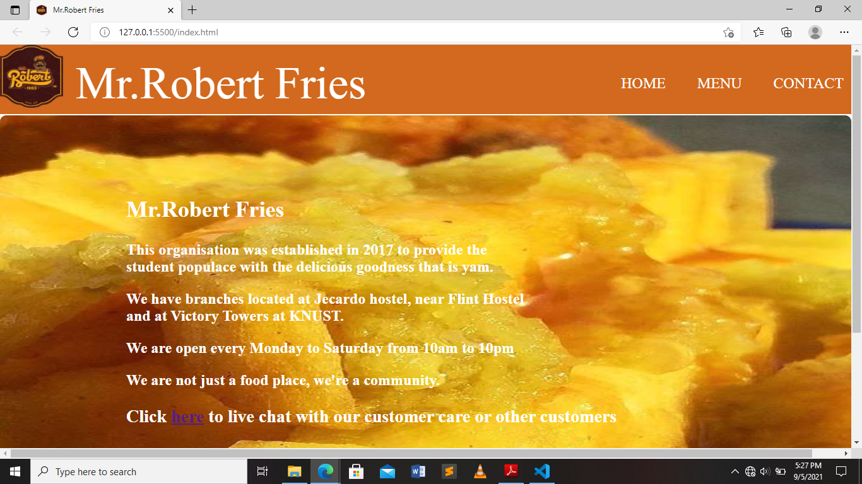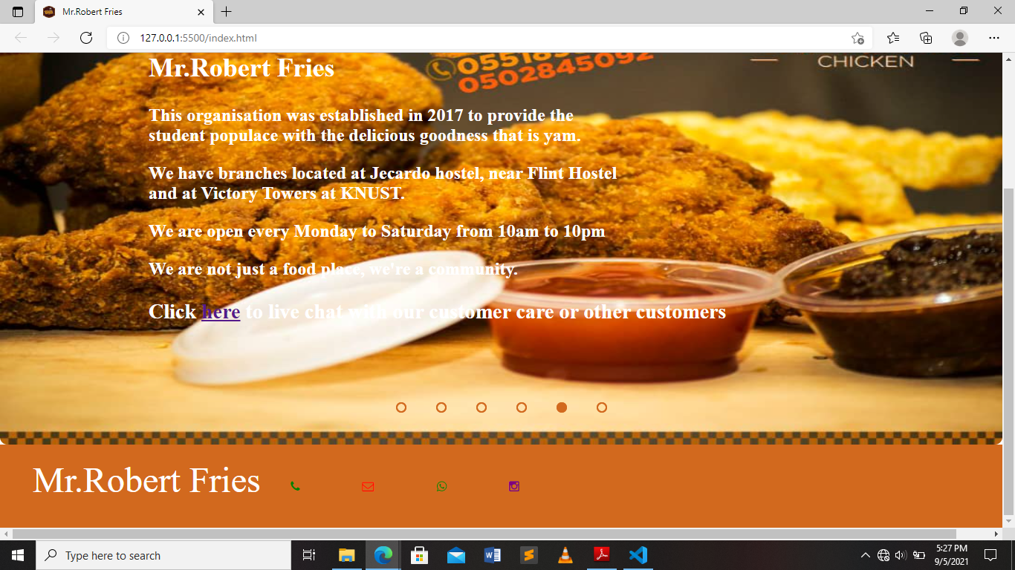

**Chat page:**

**Menu Page:**

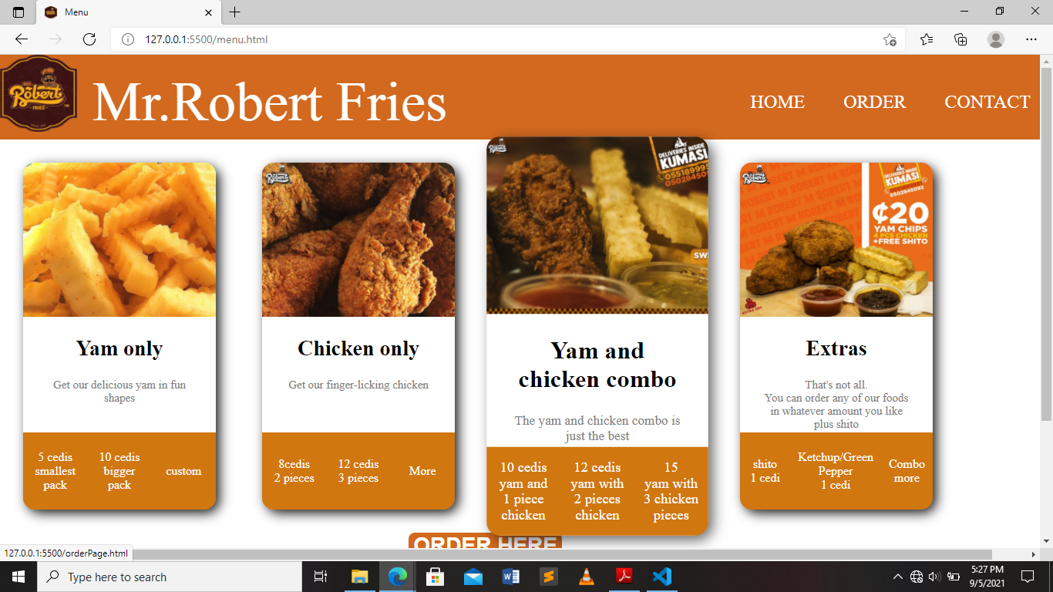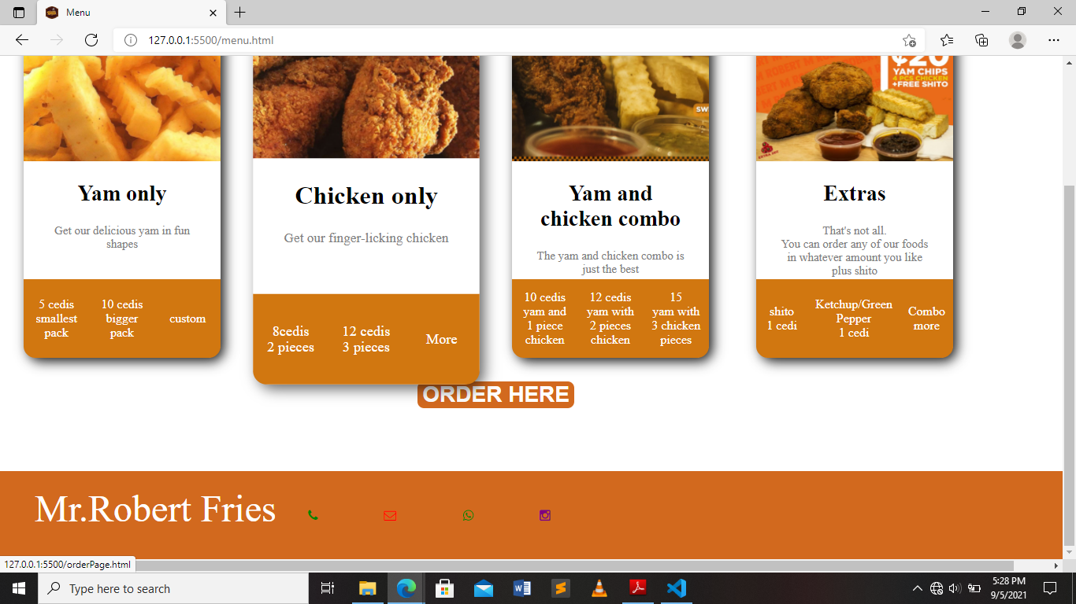

**Order Page:**

